Louise Bourgeois. The Heart Has Its Reasons
Tarmak22, Gstaad

All images: © The Easton Foundation / 2020, ProLitteris, Zurich
Courtesy The Easton Foundation and Hauser & Wirth

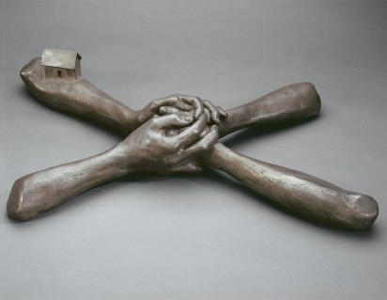
Louise Bourgeois
Untitled (No. 7)
1993
Bronze, silver nitrate patina
12.1 x 68.6 x 43.2 cm / 4 3/4 x 27 x 17 in
Photo: Christopher Burke

BOURG92046

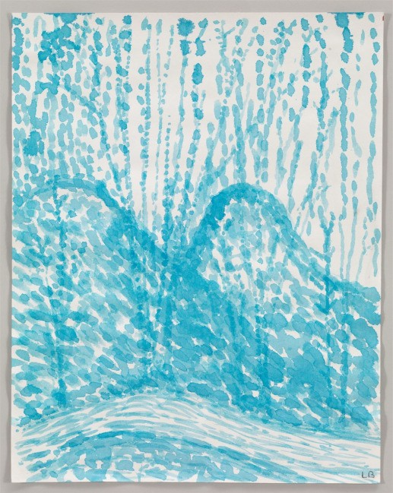
Louise Bourgeois
Untitled
2003
Watercolor on paper
28.9 x 22.9 cm / 11 3/8 x 9 in
Photo: Christopher Burke
BOURG100005

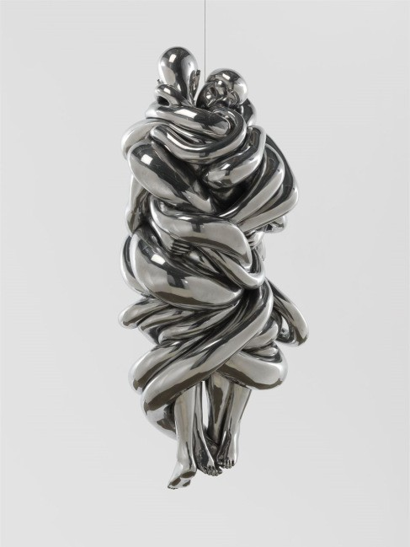
Louise Bourgeois
The Couple
2007-2009
Cast and polished aluminum, hanging piece
154.9 x 76.2 x 66 cm / 61 x 30 x 26 in
Photo: Christopher Burke
BOURG101382

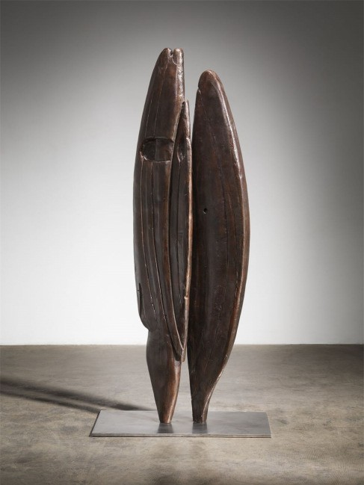
Louise Bourgeois
Brother & Sister
1949
Bronze and stainless steel
165.7 x 76.2 x 43.2 cm / 65 1/4 x 30 x 17 in
Photo: Christopher Burke
BOURG107393

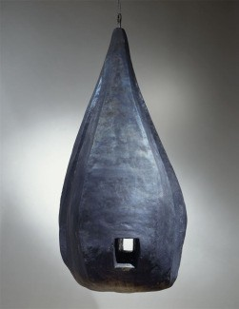
Louise Bourgeois
Lair
1986-2000
Lead, hanging piece
109.2 x 53.3 x 53.3 cm / 43 x 21 x 21 in
Photo: Christopher Burke
BOURG107394

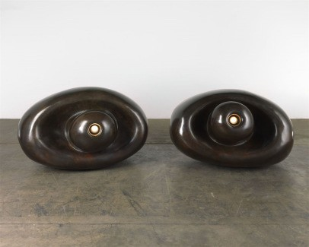
Louise Bourgeois
Eyes
2001
Bronze, golden brown patina, and electric light: a pair
One eye: 99 x 137.1 x 147.3 cm / 39 x 54 x 58 in
2nd eye: 86.3 x 147.3 x 121.9 cm / 34 x 58 x 48 in
Photo: Christopher Burke
BOURG107397

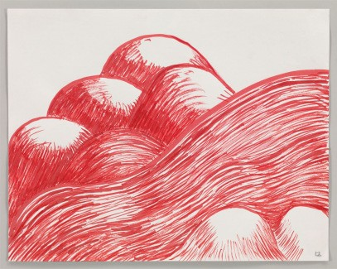
Louise Bourgeois
Untitled
2003
Watercolor on paper
22.9 x 28.9 cm / 9 x 11 3/8 in
Photo: Christopher Burke
BOURG107399

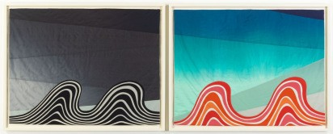
Louise Bourgeois
Night and Day
2007
Archival dyes on hand-sewn fabric, in two parts
Each: 83.8 x 106.7 cm / 33 x 42 in
Photo: Christopher Burke
BOURG107400

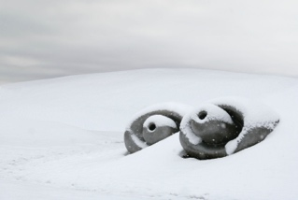
Louise Bourgeois
Eyes
2001
Bronze, golden brown patina, and electric light: a pair
One eye: 99 x 137.1 x 147.3 cm / 39 x 54 x 58 in
2nd eye: 86.3 x 147.3 x 121.9 cm / 34 x 58 x 48 in
Eyes-4786

Fair Dealing Notice

Press use is considered to be moderate use of images to report a current event or to illustrate a review or criticism of the work, as defined by the Copyright, Designs and Patents Act 1988 Chapter 48 Section 30 Subsections (1) – (3). Reproductions which comply with the above do not need to be licensed.

Reproductions for all non-press uses or for press uses where the above criteria do not apply (e.g. covers and feature articles) must be licensed before publication.

Due to UK copyright law only applying to UK publications, any articles or press uses which are published outside of the UK and include reproductions of these images will need to have sought authorisation with the relevant copyright society of that country.

Please also ensure that all works that are provided are shown in full, with no overprinting or manipulation.

UK
For further information on reproducing images licensed by DACS please visit www.dacs.org.uk or contact +44 207 336 88 11

CH
For further information on reproducing images licensed by ProLitteris please visit prolitteris.ch or contact info@prolitteris.ch / +41 (0) 43 300 66 15

Swiss : The use of these images requires the approval of ProLitteris. Legal exceptions, such as those for "reporting on current events" according to article 28 URG, are reserved. Please contact ProLitteris for further information: bildrecht@prolitteris.ch

DE
For further information on reproducing images licensed by BIld Kunst please visit www.bildkunst.de or contact info@bildkunst.de / + 49 (0) 22 89 15 340 The German image agency is VG Bild-Kunst.

FR
For further information on reproducing images licensed by ADAGP please visit www.adagp.fr or contact info@arsny.com / 33+ 01 43 59 09 79

USA
For further information on reproducing images licensed by VAGA please visit vagarights.com or contact info@vagarights.com / +1 (212) 736 66 66.

For further information on reproducing images licensed by ARS please visit www.arsny.com or contact info@vagarights.com / +1 (212) 4209160

Etc.

